Lab 10 – Worksheet

Name: Faaz Shahab, Mohib Ul Mehdi, Basim Hussain | ID: fs09911, mm09730, mh09732 | Section: T2

Task 1
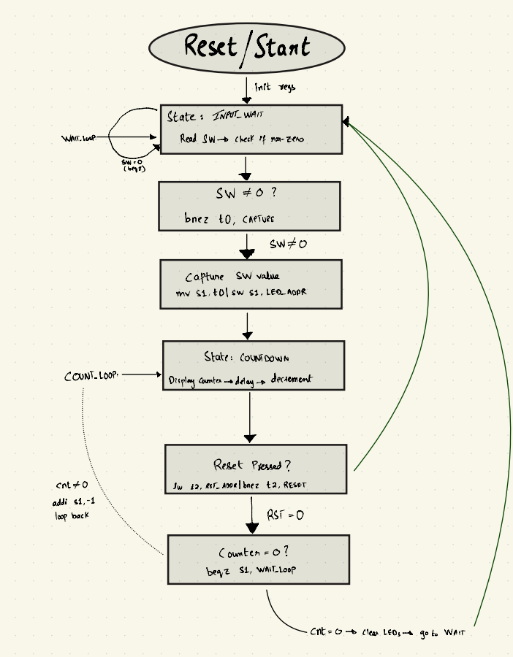

Task 2
addi x28, x0, 5
addi x2,x0,511
addi x5,x0,768
addi x6,x0,512
sw x28, 0(x5)
INPUT_WAIT:
sw x0,0(x6)
POLL_SWITCH:
lw x11,0(x5)
beq x11,x0,POLL_SWITCH
add x10,x11,x0
jal x1,COUNTDOWN
beq x0,x0,INPUT_WAIT
COUNTDOWN:
addi x2,x2,-8
sw x1,4(x2)
sw x12,0(x2)
add x12,x10,x0
COUNT_LOOP:
sw x12,0(x6)
beq x12,x0,COUNT_DONE
addi x12,x12,-1
addi x13,x0,3
DELAY:
addi x13,x13,-1
bne x13,x0,DELAY
beq x0,x0,COUNT_LOOP
COUNT_DONE:
sw x0,0(x6)
lw x12,0(x2)
lw x1,4(x2)
addi x2,x2,8
jalr x0,0(x1)
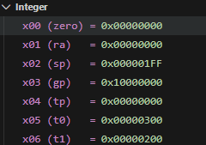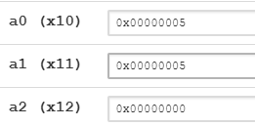
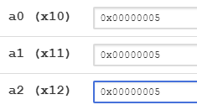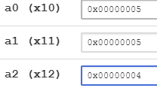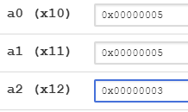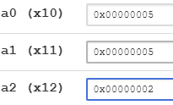
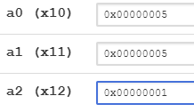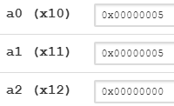
decrementing and then staying stuck at input waiting state

Task 3
Required Verilog Files attached in the folder uploaded in Github
Synthesis proof:

Assessment Rubric
Lab 09: Implementing Nested Procedures and Sorting

 | Task No. | LR 2  Code | LR 5  Results | LR 11 (Design)
In-Lab | Pre-Lab | - | /15 | -
 | Task 1 | - | - | /10
 | Task 2 | /20 | /20 | -
 | Task 3 | - | /15 | -
Total Points |  | /20 | /50 | /10
CLO Mapped |  | CLO 1

Affective Domain  Rubric |  | Points | CLO Mapped
AR7 | Report Submission & Git Upload | /10 & /10 | CLO 1

CLO | Total Points | Points Obtained
1 | 100
Total | 100

For description of different levels of the mapped rubrics, please refer to the Lab Evaluation Assessment Rubrics and Affective Domain Assessment Rubrics provided here.

Lab Evaluation Assessment Rubric
# | Assessment Elements | Level 1: Unsatisfactory | Level 2: Developing | Level 3: Good | Level 4: Exemplary
LR2 | Program/Co de/ Simulation Model/ Network Model | Program/code/simulation model/network model does not implement the required functionality and has several errors. The student is not able to utilize even the basic tools of the software. | Program/code/simulation model/network model has some errors and does not produce completely accurate results. Student has limited command on the basic tools of the software. | Program/code/simulation model/network model gives correct output but not efficiently implemented or implemented by computationally complex routine. | Program/code/simulation  /network model is efficiently implemented and gives correct output. Student has full command on the basic tools of the software.
LR5 | Results & Plots | Figures/ graphs / tables are not developed or are poorly constructed with erroneous results. Titles, captions, units are not mentioned.  Data is presented in an obscure manner. | Figures, graphs and tables are drawn but contain errors. Titles, captions, units are not accurate. Data presentation is not too clear. | All figures, graphs, tables are correctly drawn but contain minor errors or some of the details are missing. | Figures / graphs / tables are correctly drawn and appropriate titles/captions and proper units are mentioned. Data presentation is systematic.
AR9 | Report Content/Code Comments | No summary provided. The number/amount of tasks completed below the level of satisfaction and/or submitted late | Couldn’t provide good summary of in-lab tasks. Some major tasks were completed but not explained well.  Submission on time. Some major plots and figures provided | Good summary of In-lab tasks. All major tasks completed except few minor ones. The work is supported by some decent explanations, Submission on time, All necessary plots, and figures provided | Outstanding Summary of In-Lab tasks. All task completed and explained well, submitted on time, good presentation of plots and figure with proper label, titles and captions

